**Lab 3.1.B: Putting opamps to ‘gainful’ use [Negative Feedback]**

**Part B) “Complex” negative feedback**

**For Part B be sure to start from the INVERTING amplifier configuration of A.3**

In part A, for the fraction sent as feedback to the input of the opamp, we used implicitly as a real number, formed by a resistor divider.

Generalize the idea – Replace one of the resistors with a capacitor whose equivalent impedance as a complex function of frequency is

**B.1) Integrator / low pass filter**

Redesign the circuit of Part A.3 replacing one of the resistors such that the circuit works as a low-pass filter in the frequency domain, and an integrator in the time domain.

The following parts are expected for the solution:

**B.1.1)** Circuit design and equation calculation steps **2**Design your low pass filter with a corner frequency

Here, Z = R2 = 6.8kΩ and

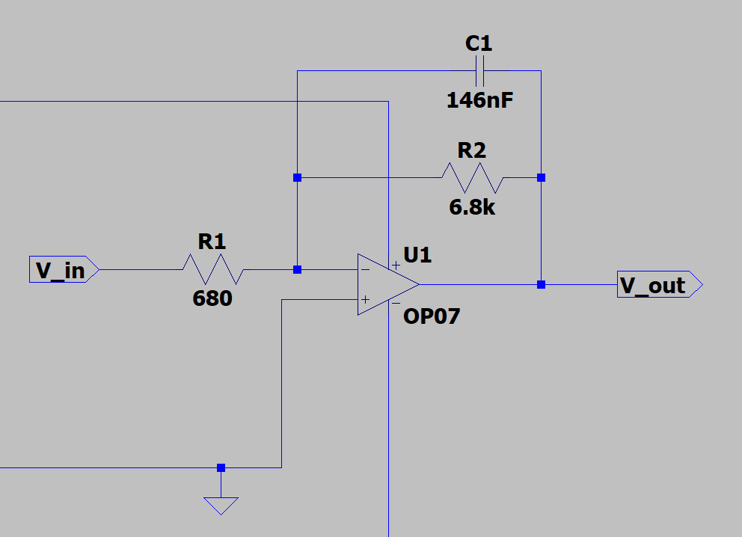

**B.1.2)** LTSpice simulation of the circuit frequency response **4**With LTSpice simulation you can check the frequency response of your circuit design and verify that it does indeed work as a low pass filter. Use an ideal voltage source as to your circuit, instead of the fixed frequency FG we are using in practice.   
Discover the tools provided in LTSpice to sweep through a range of frequencies. Perform the required signal response analysis of your circuit design and show the Bode plots below, verifying the low pass frequency as designed in (B.1.1) above

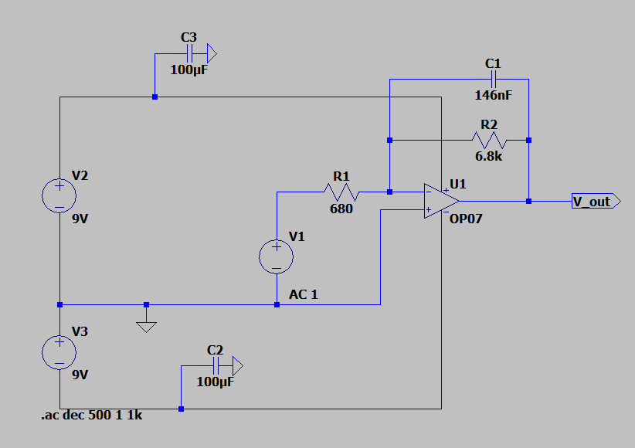

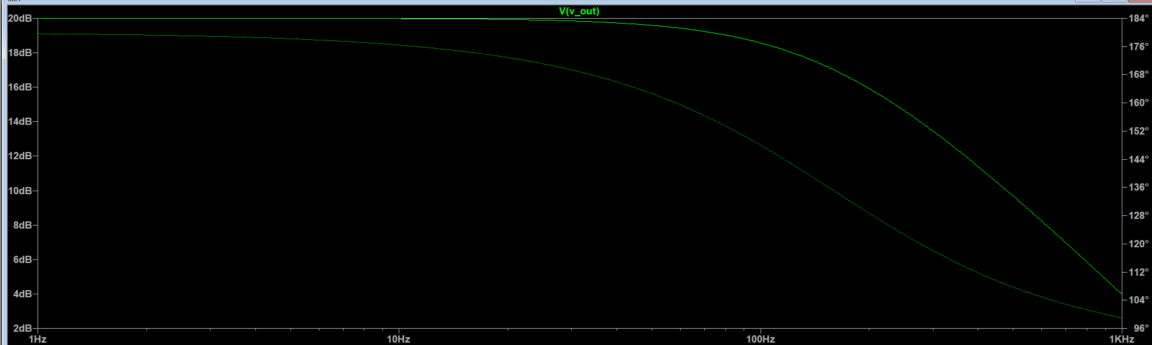

**B.1.3)** Circuit demo: time domain integrator  
In practice, you have a fixed 1kHz frequency FG on your breadboard. Hence it is not possible to check the frequency dependence of your filter circuit. However, in the time domain, a low pass filter acts as an integrator – so we will use this feature to test your circuit.  
Use the square wave output of your FG – the one produced directly from Q3 of the astable multivibrator before the R-C –C-R filters. It should be easy to guess what you expect the integration of a square wave to look like!

Provide photos of your test indicating the behavior of **6**It is be necessary to do this test in two ways to measure the initial response and the long term steady state behavior. Connect up everything in your circuit, *except* to your opamp.

1. Set your DSO to single trigger mode. As soon as you connect you will observe for the first cycle of . Record this observation with a photo.
2. Then set your DSO in auto trigger mode as usual, and record the long term steady state behavior of

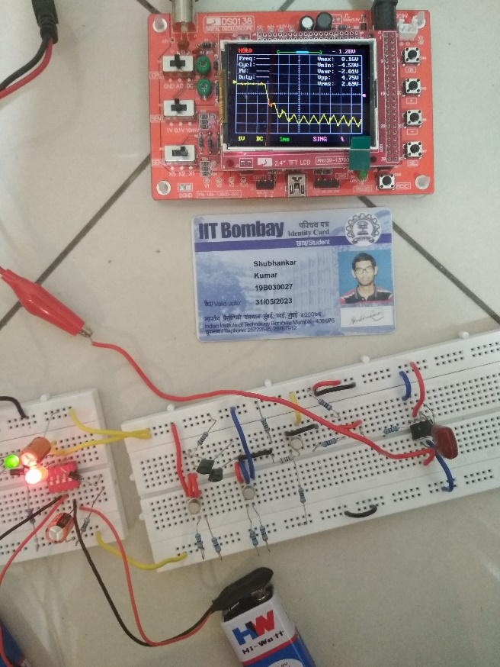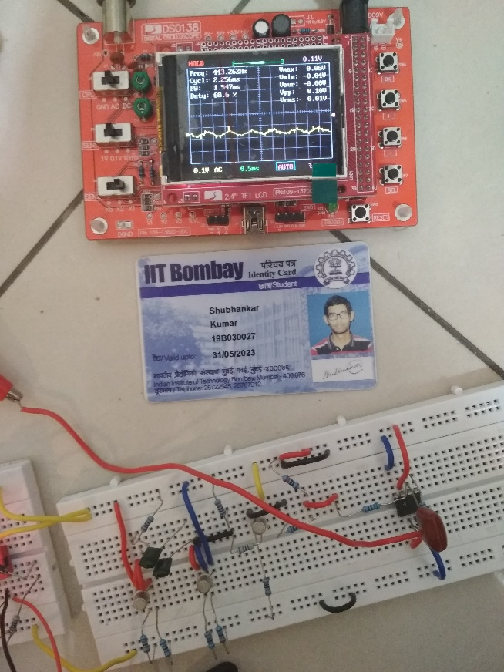

As per expectation, the integration of a long term square waveform will be a triangular waveform (image on the right).

Give a detailed explanation of your observations of initial and steady state values of measured in your experiment and how they relate to your expectation from design for ? **3**

Initial state: The integrator does not block any DC component of the input wave. Therefore the reduced amplitude output wave will have a DC component, which will be the same as the average DC level of the input wave. If the initial value of *vo* is assumed to be 0 V, this results in a DC error of:

Steady state: The above triangular wave is the output voltage when a symmetrical square wave was taken as the input voltage. The square wave takes 2 values: a or -a (both are constants). We know that the integration of a constant m wrt x will give mx+c, which is a straight line. We get a straight line of slope **a** when the square wave is **a** and a slope of **-a** when the square wave is **-a**. Overall this gives rise to a triangular output.

**B.2) Differentiator / high pass filter**

As in B.1, replace one of the resistors of the simple negative feedback design such that the circuit works as a high-pass filter in the frequency domain, and a differentiator in the time domain.

The following parts are expected for the solution:

**B.2.1)** Circuit design and equation calculation steps **2**

Design your low pass filter with a corner frequency

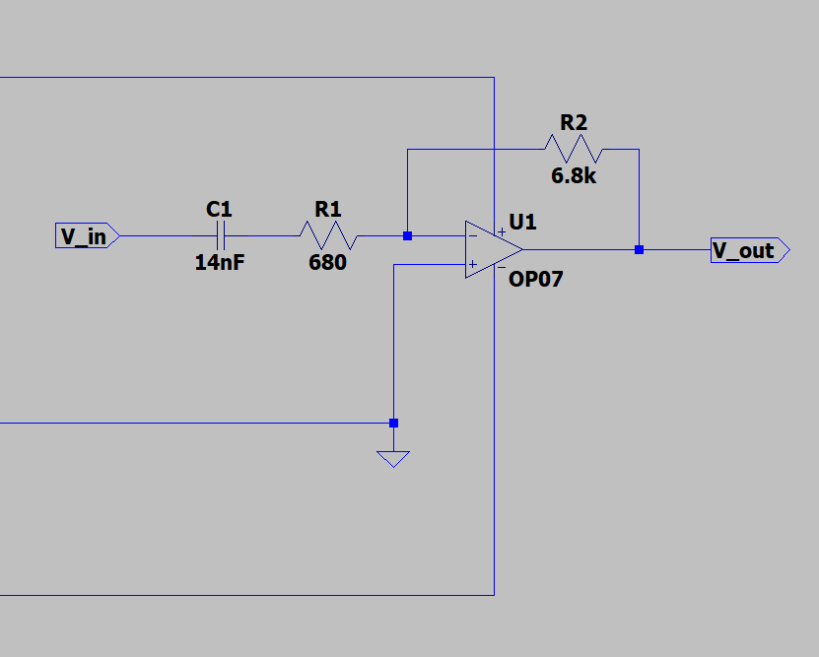

We have,

On substituting the given values of f and R1, we get

C = 14nF

**B.2.2)** LTSpice simulation of the circuit frequency response **2**As with the Integrator, run an ac signal analysis simulation to obtain a Bode plot of response   
 as a function of frequency proving that your design works as a high pass filter.

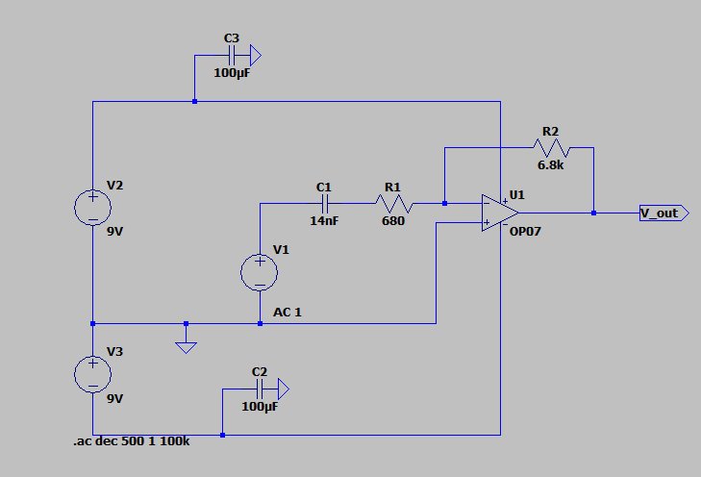

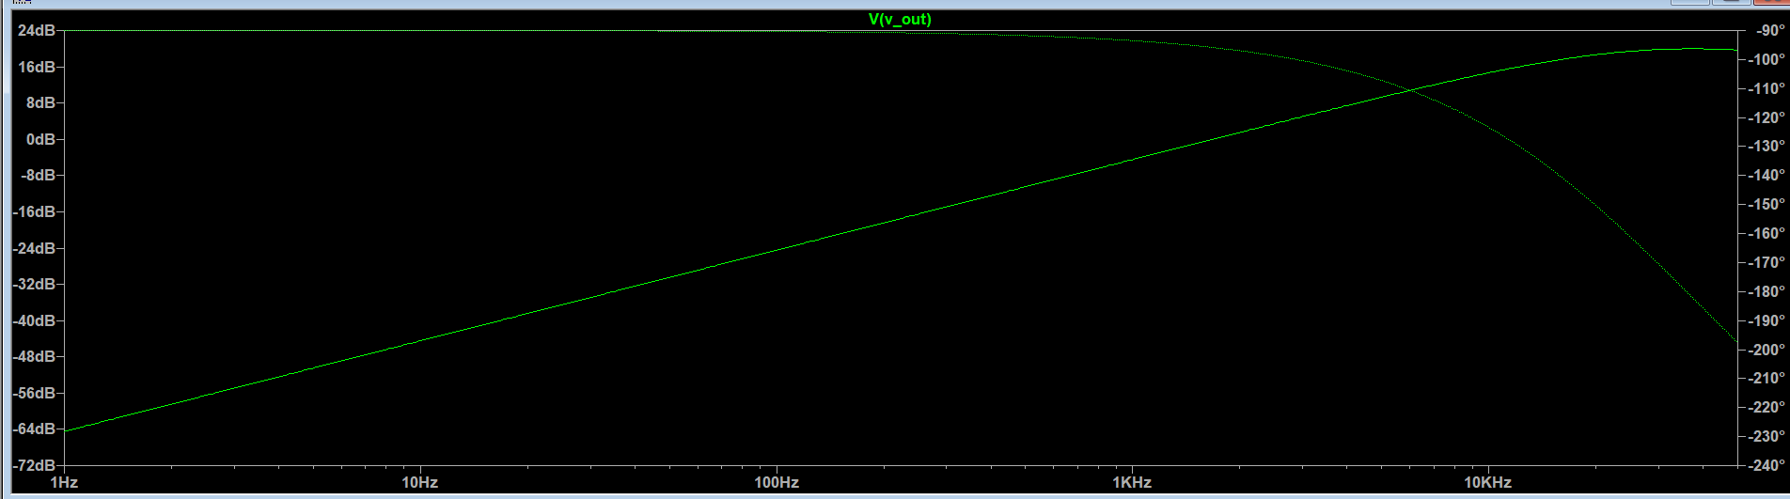

**B.2.3)** Circuit demo: time domain differentiator  
Use the square wave output of your FG – the one produced directly from Q3 of the astable multivibrator before the R-C –C-R filters. It should be easy to guess what you expect the differentiation of a square wave to look like!   
Perform the required test to demonstrate that your circuit works as a differentiator. **5**

Put labelled photos of your measured waveforms here explaining the differentiation function achieved.

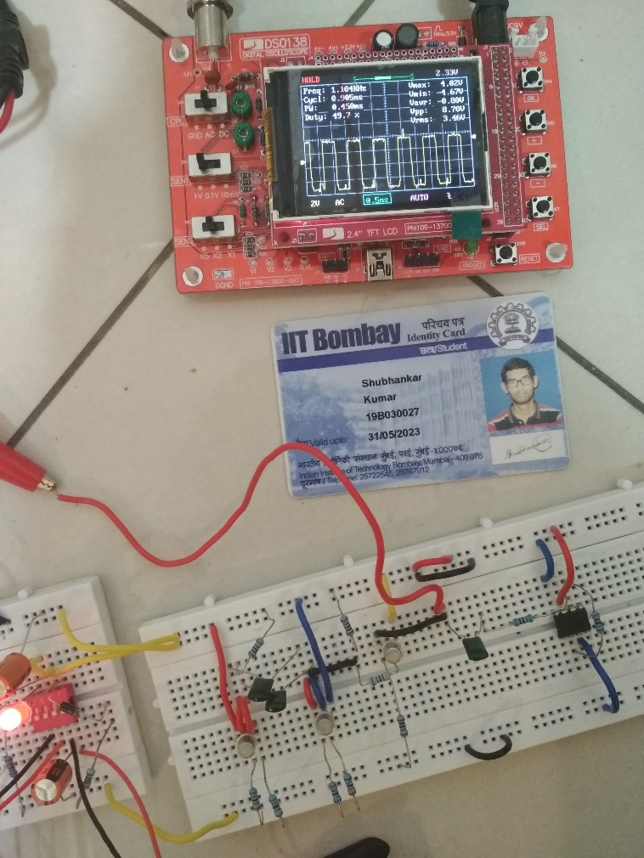

Vin

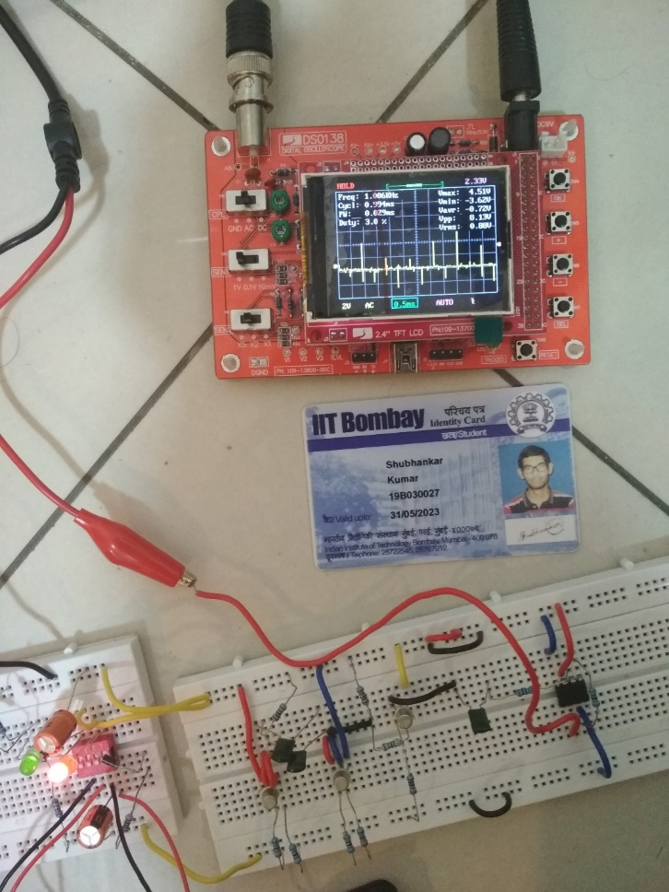

Vout

As expected, the differentiation of a square waveform will be “spikes”. Mathematically, differentiation simply mean finding a slope of a curve. Here, the slope of the curve =(y2-y1)/(x2-x1). So when the voltage of the square wave changes, the slope changes drastically, hence your get a spike (positive spike in case of up slope and negative spike in case of down slope).